Backup Verification:

Login into HPDP Backup Server.

Click On Start.

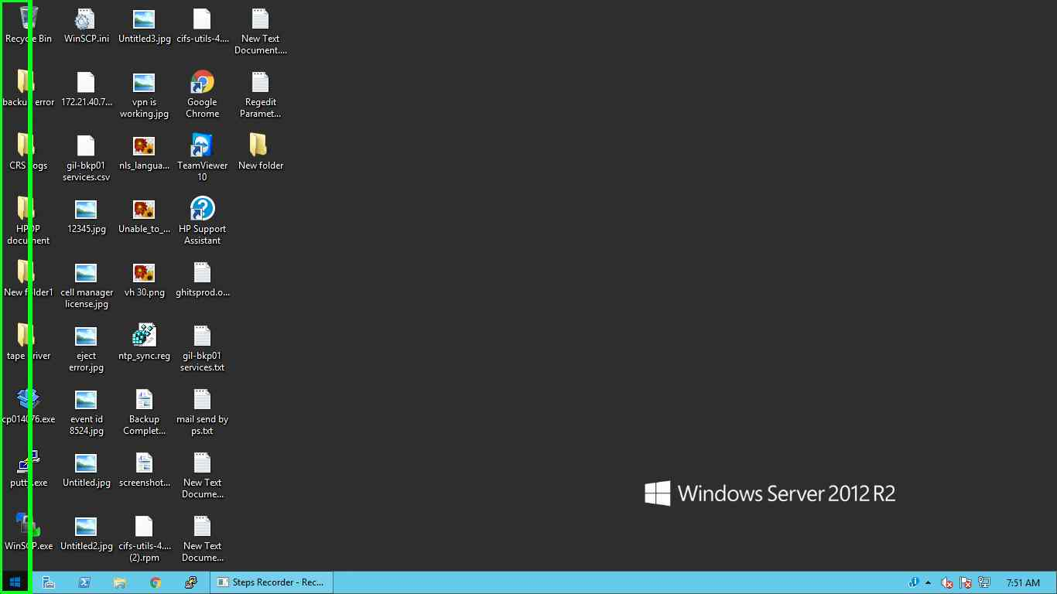

Click on "Data Protector Manager

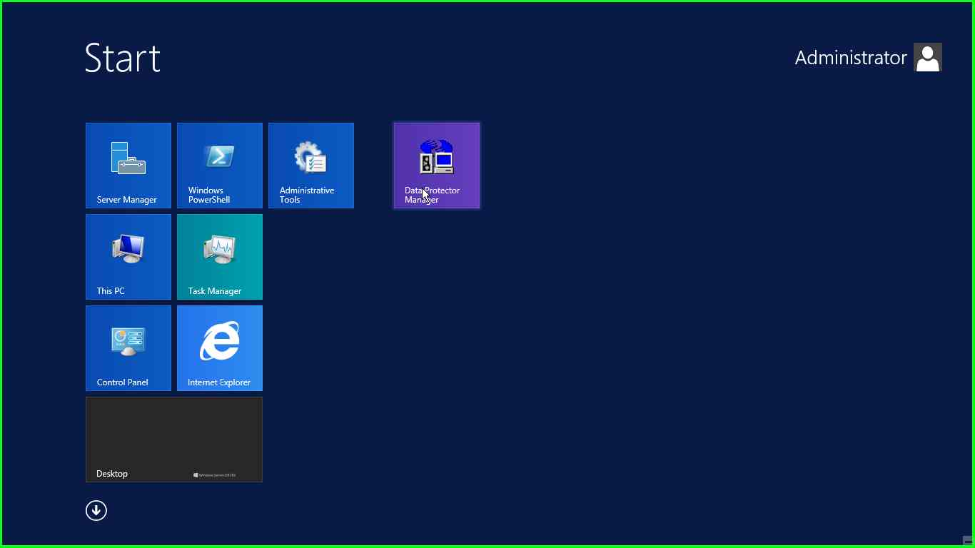

On Left Hand Side panel, From Selection Box Select Internal Database Option.

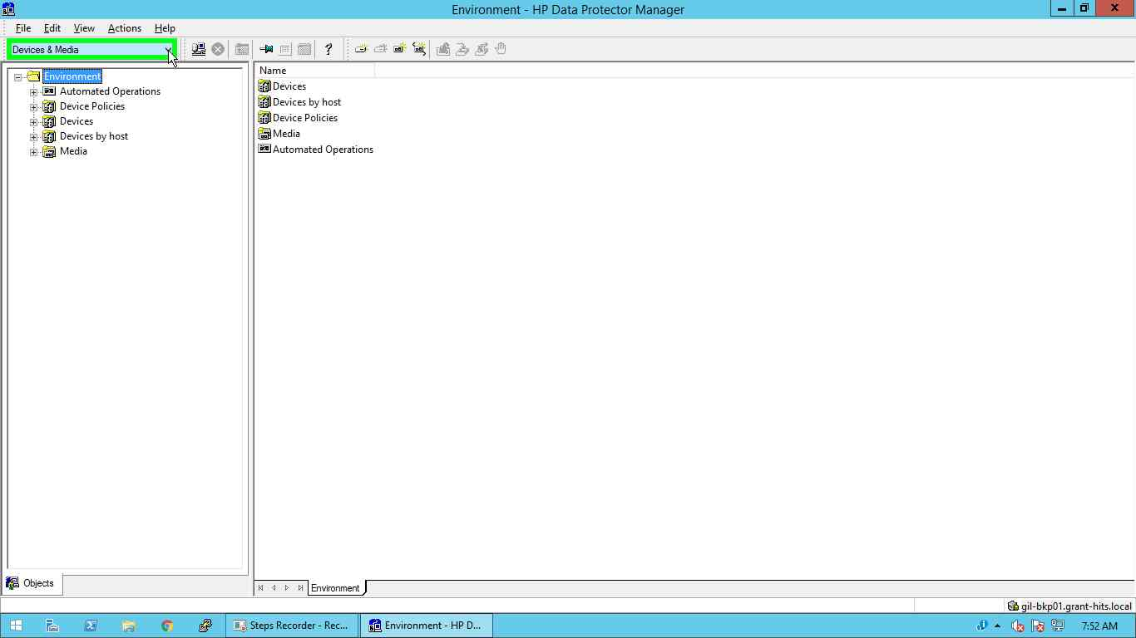

In Internal Database Select Session.

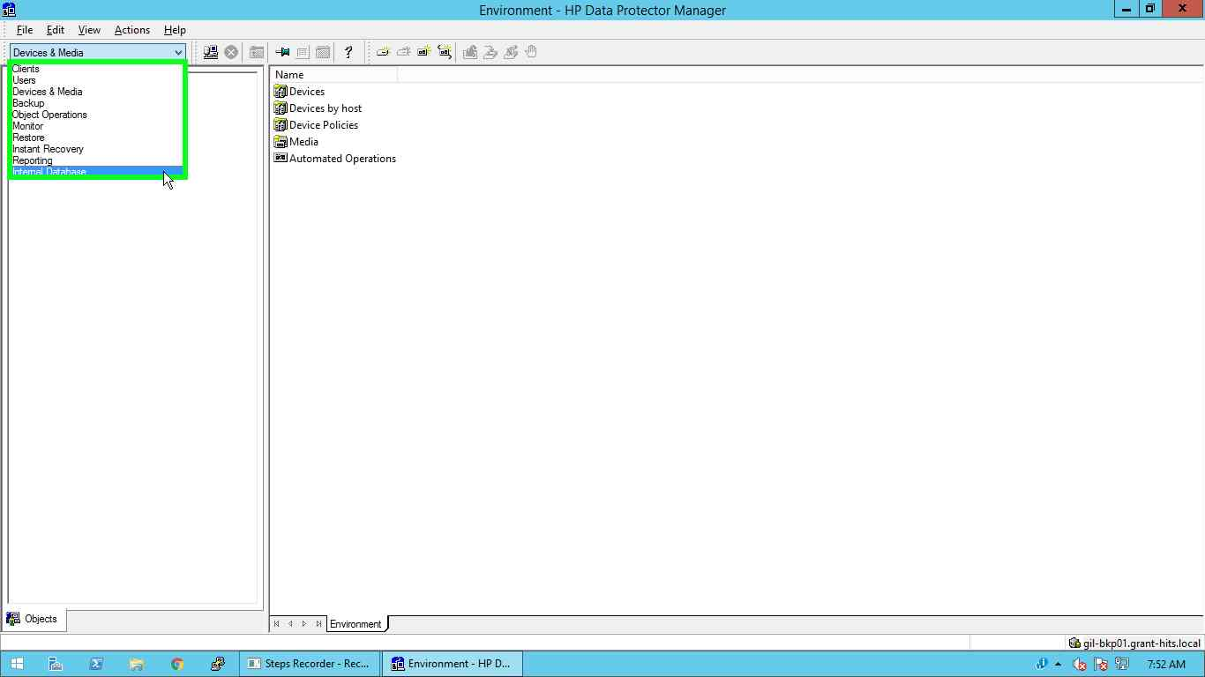

Expand Session

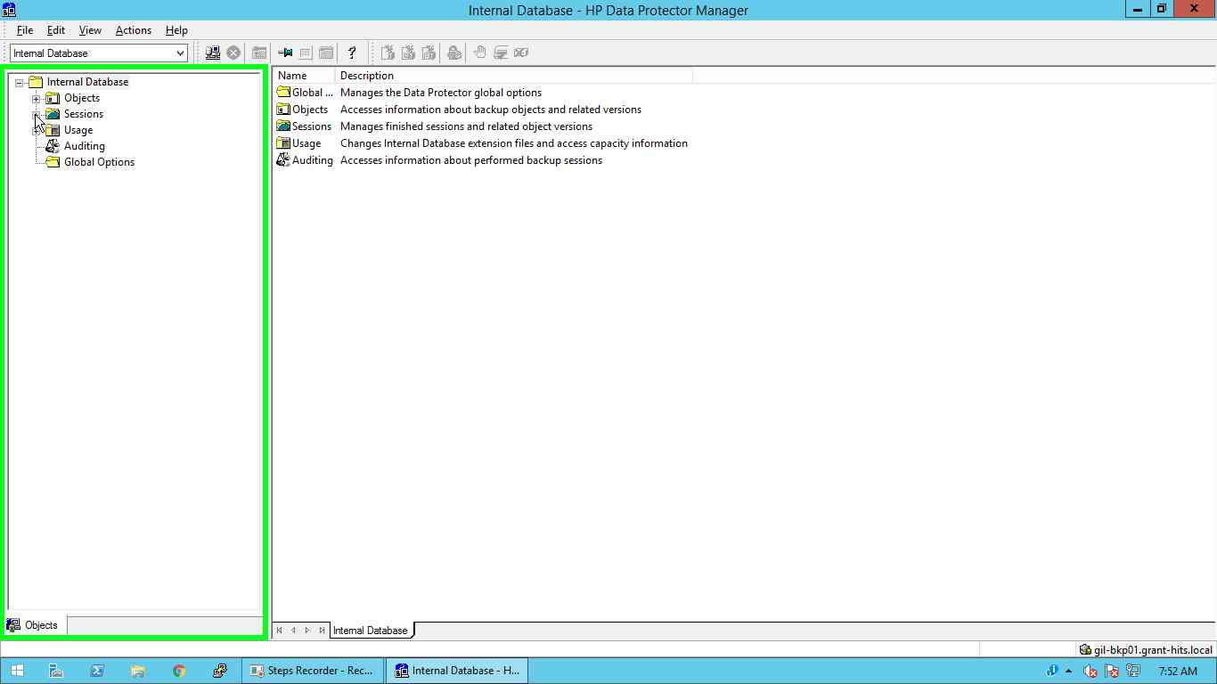

Navigate to Current Date session

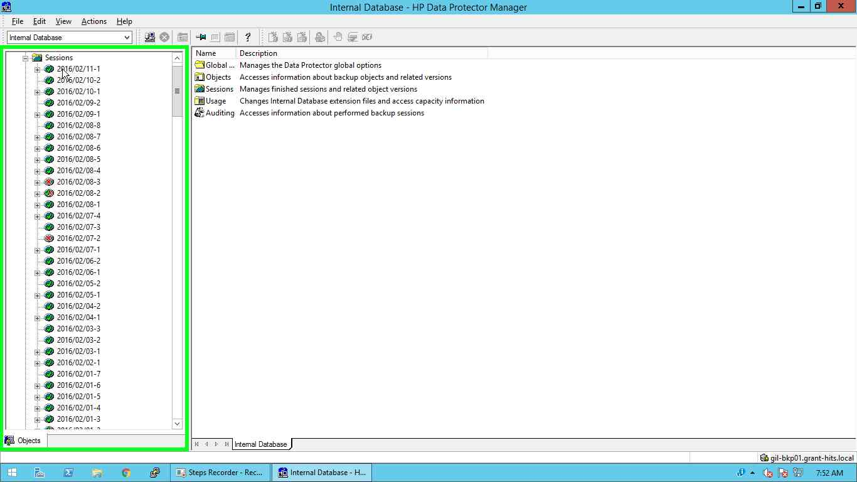

And verify all the Backup objects completed successfully or not.

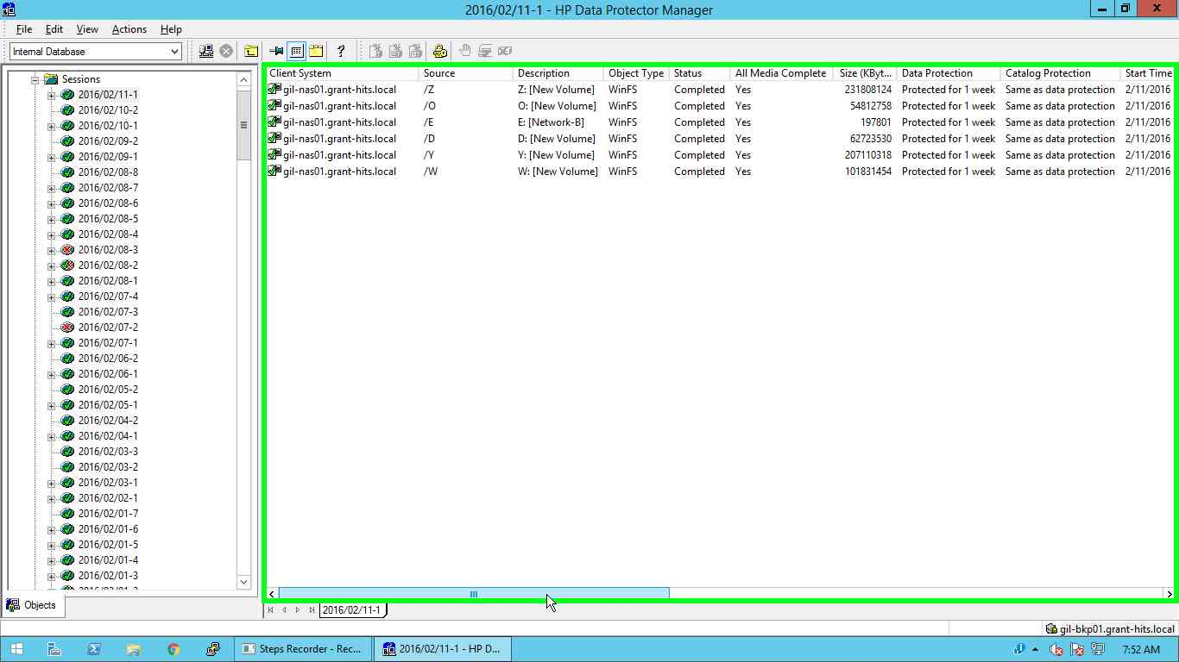

Select Device and Media from Selection Box.

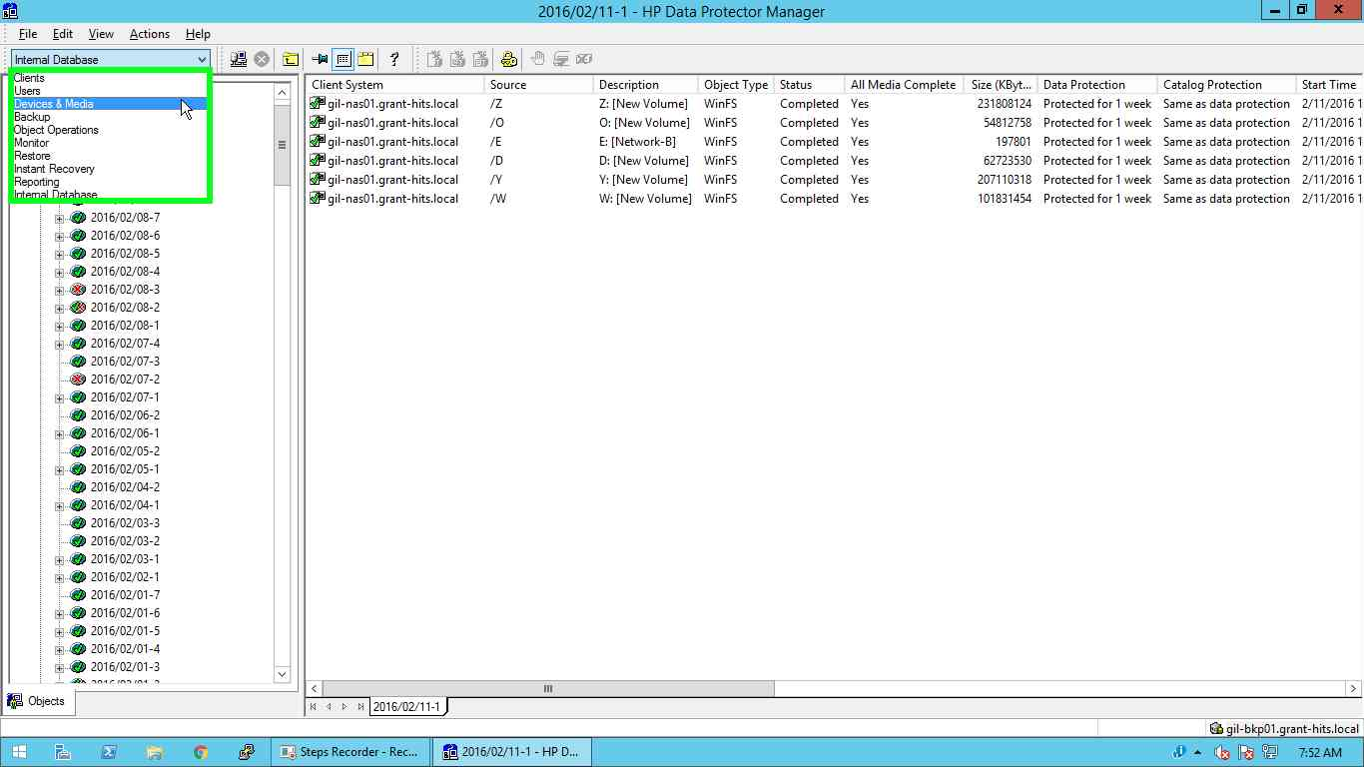

In **Device & Media** navigate to Slot (Tape Location) as follows

**Devices 🡪 GIL_BKP01_HP_MSL4048_TL🡪 Slots**.

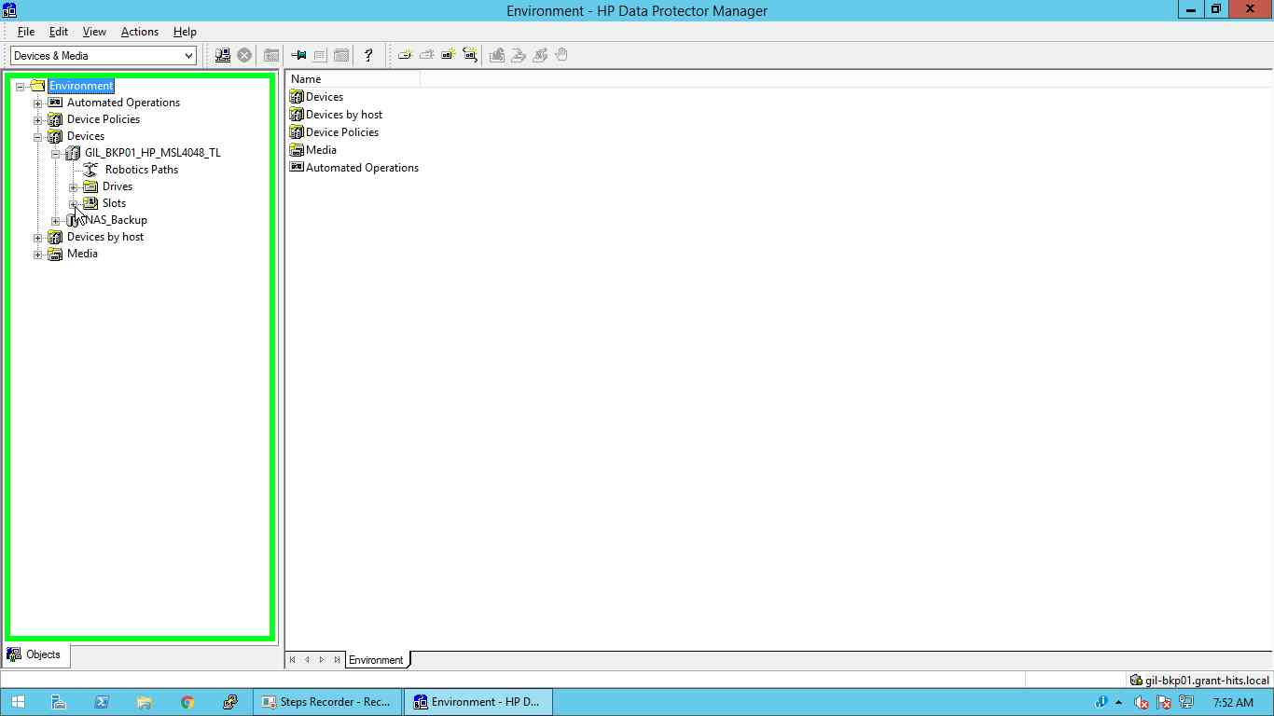

In Slot Select the Online Tape.

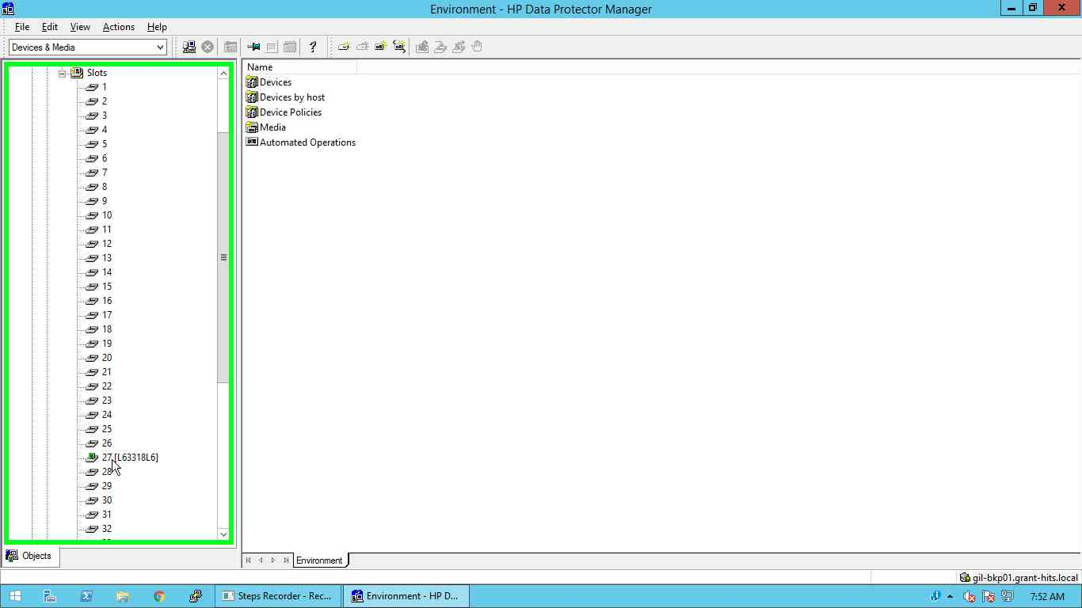

After Selecting Tape you will get Information about tape on Right Side panel.

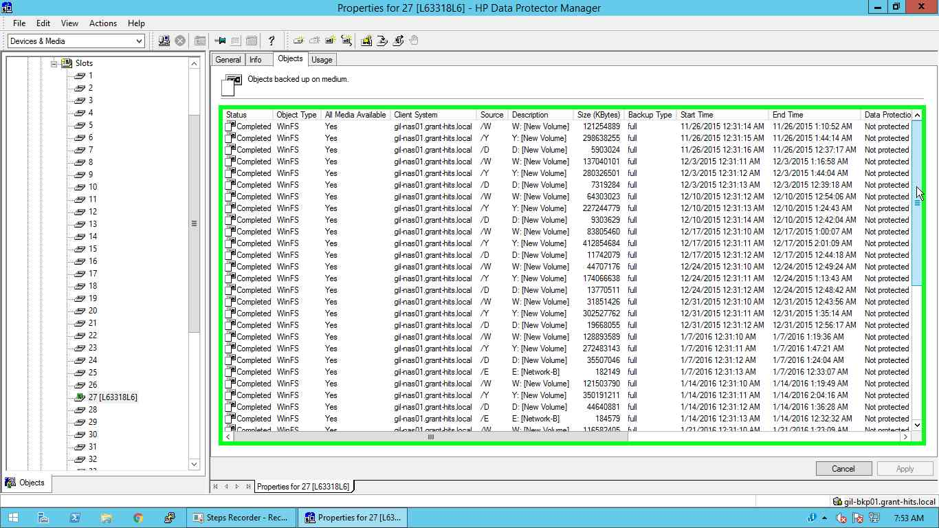

On Right Hand Side in Tape information Click on Object Tab.

And Verify all backup objects are copied on tape or not.

Compare Objects from Sessions.

